**Note:**

* **You do not have to match the output 100% to the figures / screenshot.**
* **You must use Abstract Class and Interface in your answer code.**
* **You can use Polymophism (overloading, overriding, etc) in your answer code.**

**Zoo Management**

Welcome to the Zoo Management System, a program that lets users create, view, and delete a virtual zoo. Users can **add animals** of **various types**, **view** and **interact** with them, and **delete** animals as needed. This program is designed to showcase object-oriented principles such as inheritance, polymorphism, and interfaces.

* **Main Menu**
  + Display the main menu
  + **Prompt** the user to enter an input. **Validate** the input must be a **number** and must be from **1-4**
  + **Redirect** the user to the correct menu

**Figure 1. Main Menu**

* **Create Animal Menu**:
  + Display the create animal menu
  + **Prompt** the user to enter an input. **Validate** the input must be a **number** and must be from **1-3**
  + **Prompt** the user to enter a **name** for the animal
  + **Add** the new animal to the zoo

**Figure 2. Create Animal Menu**

* **View All Animals Menu**:
  + Display **all the animals** in the zoo
  + **Prompt** the user to enter an input. **Validate** the input must be a **number** and must be from **1-n**, n being the **total number** of animals in the zoo.
  + Each animal has **specific behaviors** (e.g., making sounds, swimming, or flying).

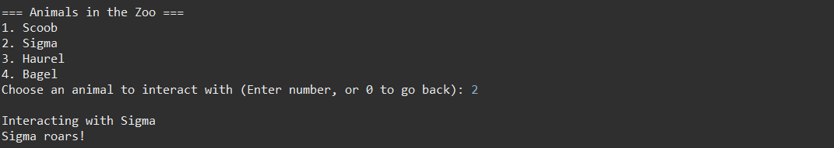

**Figure 3. View All Animals Menu (Lion)**

**Figure 4. View All Animals Menu (Fish)**

**Figure 5. View All Animals Menu (Bird)**

* **Delete All Menu**:
  + Display **all the animals** in the zoo
  + **Prompt** the user to enter an input. **Validate** the input must be a **number** and must be from **1-n**, n being the **total number** of animals in the zoo
  + **Delete** the **chosen animal** from the zoo

**Figure 6. Delete Animal Menu**

**~ Good Luck ~**